Power & Blowing Station is a vital installation. It serves the following needs of the Bhilai Steel Plant.

* Supplying air blast to Blast furnaces at requisite parameters.
* Meeting emergency power requirements of the 2.5 MT units of Bhilai Steel Plant in case of any grid power failure and also to generate power to reduce dependency on bought out power and save costs.
* Meeting the process steam needs of various shops for their safe/efficient operation.
* Buffer consumer of available Blast furnace and coke oven gasses to prevent their wastage/high pressure in the gas line network. As such the shop is required to be run at a high level of efficiency and reliability to ensure that working of other shops particularly Blast furnace are not effected

Single line diagram of Power and Blowing Station 2

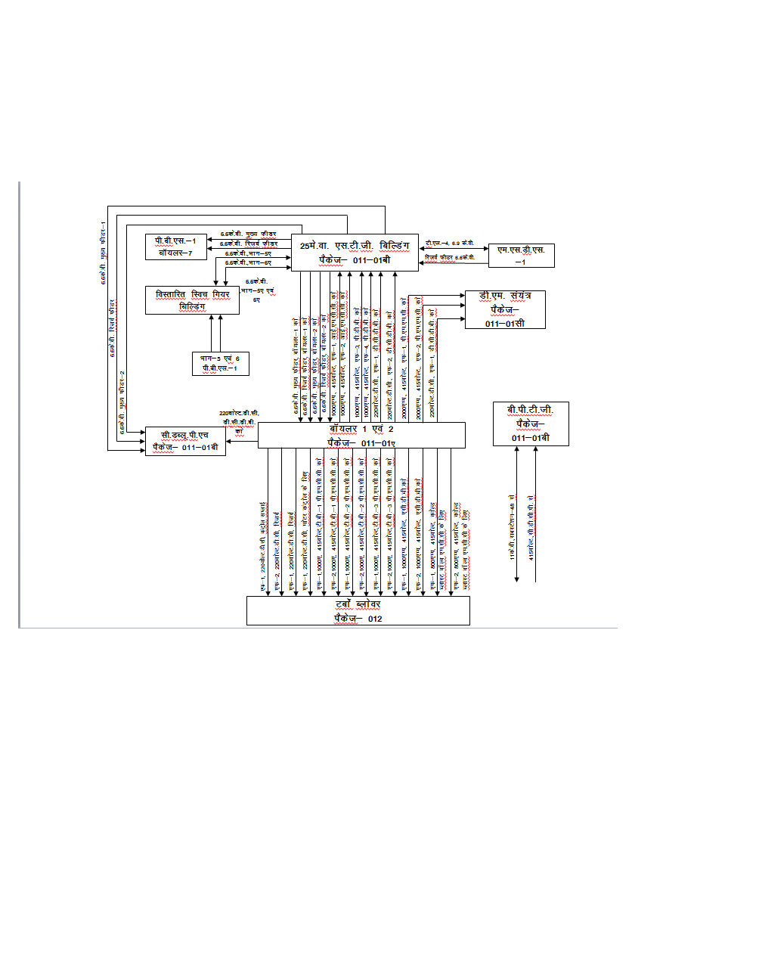

* Power and blowing station is basically meant for 74MWpower generation and is under construction with the following proposed specifications: -
* Two STGs of 30MW each: (30*2 = 60MW).
* One STG of 14MW : 14MW.

TOTAL : = 74MW.

* While P&BS 1 doesn’t use cooling tower in order to cool the “cooling water” at elevated temperature after absorbing the latent heat of vaporization of steam and works on simple water recycling system PP2 is proposed to have a cooling tower with the following specifications:-
* Four pumps of 6.6KV rated voltage and 55Amps. actual current to be run with a motor of 540KW capacity, the total energy consumption per hour being 1659.82KWhr.
* Five cooling fans of 440V rated voltage and 110 Amps. Actual current to be run with a motor of 74KW capacity,
* the total energy consumption per hour being 276.6KWhr.
* Thus the total energy consumption increased per hour for installing cooling tower at PP-2 is 1936.45KWhr.
* Though the energy consumption for installing CT at PP-2 would increase in spite of that we would be save a lot of energy as the cooling water avg. temp. would decrease and thus cycle efficiency would increase as per the formula **ŋ= (1-T2/T1), as per our study replacing the CT of PP-2 with Indirect Air cooling with Direct Contact Condenser would save 5.35 million** M3 **water and 158.30 million rupees per year!!!**

**NEED OF STEAM TURBOBLOWERS IN BSP**

Blast Furnaces can be considered as the heart of a Steel Plant. The blast furnace is the first step in producing steel from iron oxides. The purpose of a blast furnace is to chemically reduce and physically convert iron oxides into liquid iron called "hot metal". The raw materials such as iron ore, coke and limestone are dumped into the top and preheated air known as Hot air blast is blown into the bottom. The raw materials undergo numerous chemical reactions and descend to the bottom to become final product of liquid iron and slag. The hot air blast is produced by passing cold air blast trough a stove where residual blast furnace gases are burned. This cold air blast is provided by Turbo blowers form Power and Blowing Station.

Each blower installed on the new Power and Blowing station will provide on average 1500 Nm3/min of cold air blast. There will be 3 Steam Turbine driven Turbo Blowers (2 working and 1 Standby) each with 50% capacity of maximum air blast requirement.

**Site Map**



Project Packages

